**Task 2: Extended Response Cells**

Mark: __________/20

**Year 11 Human Biology 2017**

Answer the two questions below on the lined paper provided. You can choose how to structure your answer and may include labelled diagrams or tables if appropriate.

**Question 1)**

(a) Discuss the properties of enzymes, relating them where appropriate to their function.

(6 marks)

(b) Discuss in detail the ‘lock and key model’ of enzyme action. (4 marks)

**Question 2)**

(a) The following graph shows the lactic acid concentration in a test subject's bloodstream over a period of 18 minutes.

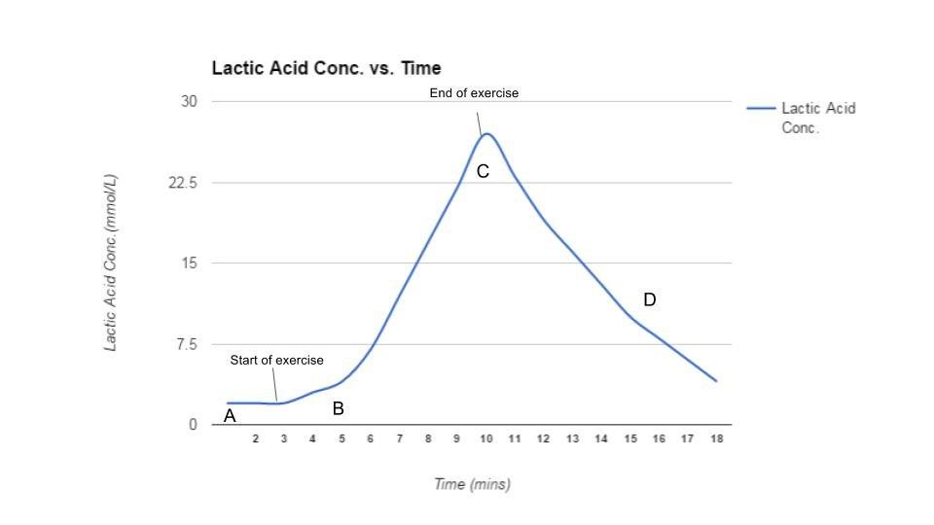

For each of the following sections of the graph, describe and explain the lactic acid concentration in the test subject's bloodstream, including relevant respiration word equations where appropriate.

(i) From point A to point B

(ii) From point B to point C

(iii) From point C to point D

(6 marks)

PLEASE TURN OVER

Question 2(cont.)

(b) Respiration is a process common to all living cells. Explain why cellular respiration is essential for maintenance of life

(4 marks)

|  |
| --- |
|  |
|  |
|  |
|  |
|  |
|  |
|  |
|  |
|  |
|  |
|  |
|  |
|  |
|  |
|  |
|  |
|  |
|  |
|  |
|  |
|  |
|  |
|  |
|  |
|  |
|  |
|  |
|  |
|  |
|  |
|  |
|  |
|  |
|  |
|  |
|  |
|  |
|  |
|  |
|  |
|  |
|  |
|  |
|  |
|  |
|  |
|  |
|  |
|  |
|  |
|  |
|  |
|  |
|  |
|  |
|  |
|  |
|  |
|  |
|  |
|  |
|  |
|  |
|  |
|  |
|  |
|  |
|  |
|  |
|  |
|  |
|  |
|  |
|  |
|  |
|  |
|  |
|  |
|  |
|  |
|  |
|  |
|  |
|  |
|  |
|  |
|  |
|  |
|  |
|  |
|  |
|  |
|  |
|  |
|  |
|  |
|  |
|  |
|  |
|  |
|  |
|  |
|  |
|  |
|  |
|  |
|  |
|  |
|  |
|  |
|  |
|  |
|  |
|  |
|  |
|  |
|  |
|  |
|  |
|  |
|  |
|  |
|  |
|  |
|  |
|  |
|  |
|  |
|  |
|  |
|  |
|  |
|  |
|  |
|  |
|  |
|  |
|  |
|  |
|  |
|  |
|  |
|  |
|  |
|  |
|  |
|  |
|  |
|  |
|  |
|  |
|  |